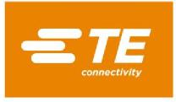

October 26, 2022

Dear Valued Supplier Partner,

As you are likely well aware, the global pervasiveness of forced/trafficked labor has led to increased awareness and increased regulation. Human Trafficking is defined as “*the recruitment, harboring, transportation, provision, or obtaining of a person for labor or services, through force, fraud, or coercion for the purpose of subjection to involuntary servitude, peonage, debt bondage, or slavery*”. TE Connectivity’s policies, including our TE [Guide to Supplier Social Responsibility](https://www.te.com/commerce/DocumentDelivery/DDEController?Action=srchrtrv&DocNm=TEC-1015&DocType=SS&DocLang=EN), requires respect for human rights and prohibits any form of human slavery or forced labor. To ensure supplier compliance with this policy, TE is partnering with [Assent Compliance](https://www.assentcompliance.com/) to conduct the following survey with our suppliers.

**The Assent Human Trafficking and Slavery survey module will utilize the Slavery and Trafficking Risk Template (STRT) which is an industry standard survey used to collect human trafficking and slavery data from the supply chain**. If this is your first contact with the STRT, please review the instructions on the first page of the template. Your prompt completion of this survey will help TE meet current environmental, social, and governance (ESG) expectations. The survey is designed to facilitate the collection of relevant data and supporting documentation, when needed.

Please ensure this survey is completed by the appropriate person in your organization and submitted through the Assent system.

Together we can combat Human trafficking. Thank you in advance for your support and timely completion of the survey.

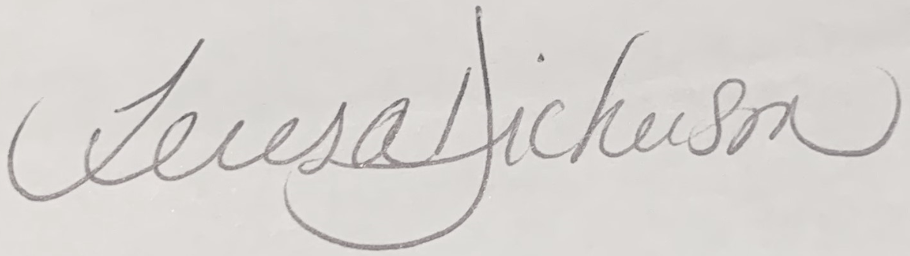

Teresa Dickerson

VP & Chief Procurement Officer