What is COPQ (Cost of Poor Quality)?
March 11th, 2024
Quality issues can significantly impact a company’s profitability and reputation. To quantify the financial impact of poor quality, the concept of cost of poor quality (COPQ) is used.
COPQ refers to all the costs associated with preventing, finding, and correcting defective work. It provides a metric to understand the cost of quality problems and drive improvement initiatives.
Tracking COPQ enables organizations to identify processes that need attention, set quality improvement goals, and allocate resources effectively.
It is an essential metric that highlights the financial benefits of achieving higher quality standards. Analyzing and lowering COPQ can directly increase profitability, along with improving operational efficiency and customer satisfaction.

What is the Cost of Poor Quality (COPQ)?
Cost of poor quality (COPQ) refers to the costs associated with producing defective products or services that fail to meet customer expectations. It highlights the extra costs incurred due to poor processes or systemic issues that allow defects, errors, and quality issues to occur.
COPQ quantifies the costs linked to preventing, finding, and correcting issues to ensure quality. It provides visibility into quality management costs and performance.

Categories of costs: COPQ is broadly divided into four categories
- Prevention costs: Expenses incurred to prevent defects like training, quality planning, etc.
- Appraisal costs: Inspection, testing, and audits to identify issues.
- Internal failure costs: Expenses from defects found before delivery to the customer.
- External failure costs: Costs occurring after delivery due to returned products, complaints, etc.
Tracking COPQ highlights areas for improvement in processes and systems to reduce overall costs.
It is a key metric for quality control across manufacturing, service, and transactional domains.

Why Measure Cost of Poor Quality
Understanding the cost of poor quality is critical for organizations looking to improve profitability, efficiency, and customer satisfaction.
Tracking quality costs allows businesses to identify problem areas, benchmark performance over time, and prioritize quality improvement initiatives.

Impact of COPQ on Profits
The cost of poor quality has a direct impact on an organization’s bottom line. These costs drain profits and can account for a surprising percentage of operating expenses.
By measuring quality costs, companies can determine exactly how much money is being lost to rework, scrap, returns, and other quality issues.
Reducing these costs through process improvements and quality control boosts profit margins.

Identify Problem Areas with COPQ
Analyzing quality cost data allows organizations to pinpoint processes, products, or services responsible for the highest defects and failures.
For example, tracking repair and warranty expenses by product line or business unit spotlights which areas incur the greatest quality costs. Companies can use this information to focus quality improvement projects on problem processes first.

Benchmark Performance
Tracking quality costs over time provides an ongoing benchmark to measure performance improvements.
As initiatives like Six Sigma and ISO 9001 reduce errors, organizations can quantify savings in prevention, appraisal, and failure costs. Comparing the current cost of poor quality metrics to past performance illustrates tangible financial gains from quality programs.
Firms can also use industry benchmarks to evaluate how their quality costs stack up against competitors.
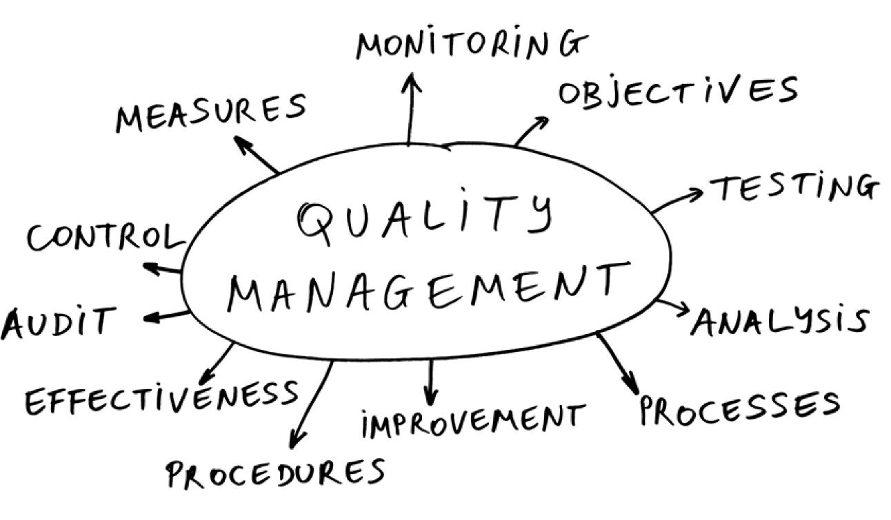

Calculating the Cost of Poor Quality (COPQ)
Understanding the different components of quality costs is essential for calculating the total cost of poor quality. According to quality management principles, quality costs can be divided into four categories:

Prevention Costs
Prevention costs refer to the costs incurred to prevent defects and errors from occurring in products or services. Some examples of prevention costs include:
- Costs of new product review and planning activities
- Process analysis costs
- Quality planning costs
- Supplier quality evaluation costs
- Quality training costs
- Costs of maintaining test equipment
Tracking prevention costs helps identify areas for future investment to prevent nonconformities. Generally, higher prevention costs lead to lower failure costs.

Appraisal Costs
Appraisal costs relate to the costs incurred to evaluate processes and products to ensure conformance to quality standards. Some examples of appraisal costs include:
- Inspection costs
- Testing costs
- Equipment calibration and maintenance costs
- Costs of quality audits
- Field testing and evaluation costs
Appraisal costs help verify quality requirements before products reach customers. However, analyzing appraisal costs can identify opportunities to streamline quality control activities.

Internal Failure Costs
Internal failure costs are incurred when products or services fail to meet quality standards before delivery to customers. Some examples are:
- Costs of rework and repairs
- Scrap costs
- Material review costs
- Costs related to reinspection and rescheduling
- Downtime costs due to quality issues
Analyzing internal failure costs identifies problem areas in processes for future corrective action.

External Failure Costs
External failure costs occur when the product or service fails after delivery to the customer. Some examples include:
- Warranty costs
- Liabilities arising from quality issues
- Costs of customer returns and replacements
- Lost sales opportunities
- Costs associated with customer complaints
Monitoring external failure costs is imperative as it directly impacts customer satisfaction levels and brand reputation.
Tracking costs in each of these categories provides critical insights for quality improvement initiatives. The goal is to reduce total quality costs by preventing defects and errors. This requires increasing prevention costs and reducing failure costs over time.
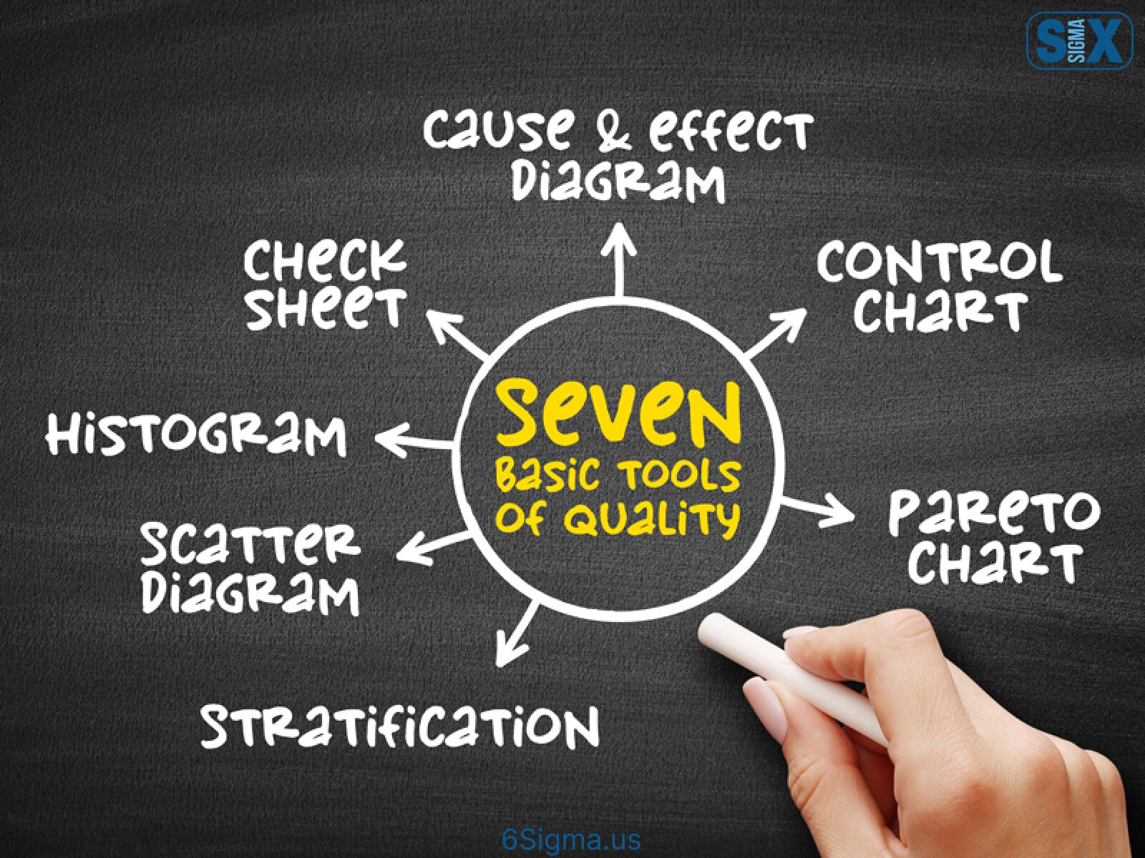

Analyzing the Cost of Poor Quality Data
Once the cost of poor-quality data has been collected, it needs to be analyzed to identify opportunities for improvement.
Thorough analysis provides insights into the largest contributors to quality costs and helps determine the most impactful areas to focus process improvement efforts.
There are a few key ways to analyze quality cost data:

Failure vs Prevention Costs
A useful analysis is to compare failure costs (costs incurred from defects) to prevention costs (costs of activities to prevent defects).
The goal is for prevention costs to exceed failure costs, as this shows that proactive efforts are being invested in quality. A higher percentage of failure costs indicates reactive quality efforts and room for improvement.

Direct vs Indirect Costs
Costs can also be categorized as direct or indirect. Direct costs are easily traceable to a quality failure like material scrap.
Indirect costs are harder to connect and estimate like lost sales or customer dissatisfaction. Evaluating the magnitude of indirect vs direct costs highlights the greater business impact of quality beyond operations.

Trend Analysis with COPQ
Analyzing quality costs over time instead of a single snapshot better indicates progress. Quality cost data can be tracked periodically to identify trends and correlate quality initiatives to their financial impact.
Comparing the cost trends to process metrics like defects per unit or first pass yield provides further context into what is driving changes in quality costs.
Significant reductions in the cost of poor quality and increases in prevention costs signal the maturity of the quality system.


Strategies to Reduce Cost of Poor Quality
Reducing quality costs should be a strategic priority for organizations looking to improve profitability. There are several effective strategies to lower quality costs:

Process Improvement Methodologies
Implementing process improvement methodologies like Six Sigma and Lean helps reduce variations and defects.
These provide a data-driven approach to analyze processes, identify root causes of problems, and implement solutions. Key techniques include:
- Define, Measure, Analyze, Improve, Control (DMAIC) – The core Six Sigma approach to optimize processes
- Value stream mapping – Documents process flows to identify waste
- 5S – Workplace organization for efficiency
- Error proofing – Design processes to prevent defects

Quality Management Systems with COPQ
A quality management system like ISO 9001 provides a framework to implement quality best practices across the organization.
This includes quality planning, control of documents and records, handling non-conformances, audits, corrective actions, and continual improvement.

Training and Culture
Training employees on quality awareness and building a culture of quality is essential. This includes leadership commitment, employee empowerment, and recognition programs.
A strong quality culture enables long-term gains over short-term workarounds.

Automation
Automating certain process steps reduces variability induced by human errors.
This includes automated inspection systems, testing equipment, machine monitoring, etc. that provide objective data. However, over-automation should be avoided.
Implementing a combination of these strategies in a planned manner will significantly cut down poor quality costs and boost profits.
The key is to promote quality within the organizational culture.

Benefits of Reducing the Cost of Poor Quality
Reducing the cost of poor quality can have significant benefits for an organization. Here are some of the major advantages:
Measuring and analyzing the cost of poor quality allows companies to identify areas for improvement. By implementing changes to reduce defects, rework, and waste, organizations can see several positive effects.

Increased profitability with COPQ
Lowering quality costs directly improves profits, as less money is spent on scrap, repairs, returns, etc. Companies can then allocate these savings to growth initiatives.
Reducing errors also minimizes lost sales opportunities from dissatisfied customers.

COPQ Contributing Towards Improved Efficiency
With fewer defects occurring, less time is spent reworking products to meet specifications. Smooth processes waste fewer materials and require less human effort per output.
This allows capacity to be directed at revenue-generating activities.

Better customer satisfaction
High-quality products that meet requirements consistently lead to improved customer satisfaction. With fewer complaints and returns to process, customers have a better brand experience. This builds loyalty and can support higher sales volumes and pricing power.
By benchmarking quality costs, pursuing targeted improvements, and creating a culture of quality, companies stand to gain financially while also strengthening market positioning through enhanced customer satisfaction.
- Tracking the cost of poor-quality metrics provides the business intelligence to guide these beneficial changes.
- Cost of poor quality refers to the costs associated with defects and failures in products or services. It includes prevention costs, appraisal costs, internal failure costs, and external failure costs.
- Measuring the cost of poor quality is important to understand its impact on profits, identify problem areas for improvement, and benchmark performance.
- Prevention costs relate to activities that prevent defects, appraisal costs involve inspecting for defects, internal failure costs arise from defects found before delivery, and external failure costs occur after delivery.
- Analyzing the cost of poor-quality data involves comparing failure versus prevention costs, direct versus indirect costs, and conducting trend analysis.
- Strategies to reduce costs include process improvement methodologies like Six Sigma and Lean, implementing quality management systems, training, culture building, and automation.
- The benefits of reducing the cost of poor quality include increased profitability, improved efficiency, better product quality, and enhanced customer satisfaction.
Quantifying and analyzing the cost of poor quality provides visibility that drives strategic quality initiatives.
This ultimately translates to substantial savings and competitive advantage for businesses. Adopting a culture of continuous improvement is key to minimizing quality costs on an ongoing basis.

Cost of Poor Quality (COPQ) is the cost associated with producing poor-quality products or services for the customer. In other words, it is the total financial losses incurred by the company due to errors and subpar work. For example, scrap, rework, repair, and warranty failure all add to the cost of poor quality.
Cost of Quality is a methodology used in the organization to measure the resources used for good quality. In other words, it is the cost of making quality products or services.
Cost of Quality combines the cost of good quality and the cost of poor quality.
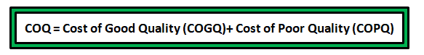

Why Cost of Poor Quality (COPQ) Matters
- It tells how profit is affected by the quality.
- Speaks management’s language.
- Helps to prioritize improvement actions
- Optimize the resources and also help identify waste in the system.
- Improves continuous improvement culture

Categories of Cost of Quality
The cost of quality can be divided into four categories: prevention cost, appraisal cost, internal failure cost, and external failure cost.
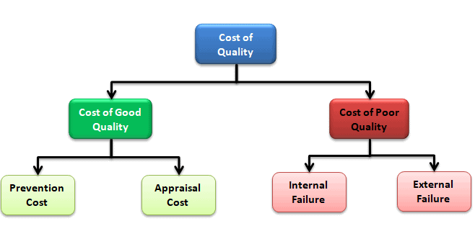
Preventive Cost– Preventive costs are the costs of activities that are specially designed to prevent poor quality of products or services. In other words, these efforts ensure that failures never happen in the first place.
- Quality planning
- Contract review
- Trainings
- Quality audits
- Supplier evaluation
- Market research
- Process capability studies
Appraisal costs–Appraisal costs are incurred when the company pays a consultant or expert to find the causes of the poor quality of the product or service. In other words, appraisal costs are related to testing, measuring, and auditing. The appraisal cost focuses on the discovery of defects rather than the prevention of defects.
- Incoming goods inspection
- In-process inspection
- Supplier inspection
- Laboratory testing
- Final goods inspection
- Calibration
Internal failure–Internal failure costs result from the finding of defects prior to delivery of the product or service to the customers. In addition, these are the costs due to the failure of a product to achieve the required quality standards.
- Rework
- Repair
- Internal scrap
- Re-testing
- Efforts spent on failure analysis
- Raw material rejects
- In-process rejects
External failure–External failure costs arise from the rejection of the product or services by the customers after delivery. In other words, these are the costs when a product or service fails to meet the required quality standards and is detected after it reaches the customer.
- Warranty claims
- Customer visits
- Penalties
- Replacements
- Investigations
- Loss of goodwill

When to use Cost of Poor Quality (COPQ)
Organizations use COPQ to understand the opportunities to improve quality by reducing internal and external failure costs. They do this by spending more on preventing problems than fixing them.

Steps in implementing Cost of Poor Quality (COPQ)
- Define the organization’s quality goals and objectives
- Estimate the current capabilities of machines, systems, and processes
- Collect data for prevention cost, appraisal cost, internal failure cost, and external failure cost.
- Validate the quality cost data with finance
- Pareto the quality costs and adopt an action-first mindset
- Implement corrective actions such as automating the quality audits, streamlining the inspection process, implementing Poka-Yoke, etc.
- Compare the quality costs before and after you have implemented the above steps. Check out the figure shown below for an example.
- Finally, present the new quality cost model to top management.
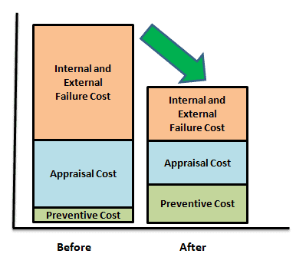

Example of Cost of Poor Quality (COPQ)
Quality assurance is everything for an organization. Incorporating Six Sigma and other Lean tools allows companies to reduce waste (Raw materials, Logistics costs, and unnecessary man hrs) which increases their bottom line.
Let’s say you are running a DMAIC project. In the define phase, you want to quantify the cost of poor quality. You start by defining what a defect is. Then, you measure how many defects per million opportunities your process has (You would use this same material to create your baseline sigma in the measure phase, next).
Example: Imagine producing TVs, and for every 1M produced, 2% were damaged. That’s 20,000 TVs. If those damages were not salvageable, and it cost $100 to produce each unit, then it costs your company 20k *$100 = $2 Million.
But that’s not all. How many people would you need to hire for re-inspection, warranty repair, supplier evaluation, etc.? Here you go for the breakup of the costs. Below is the split-up of various costs (Just as an example).
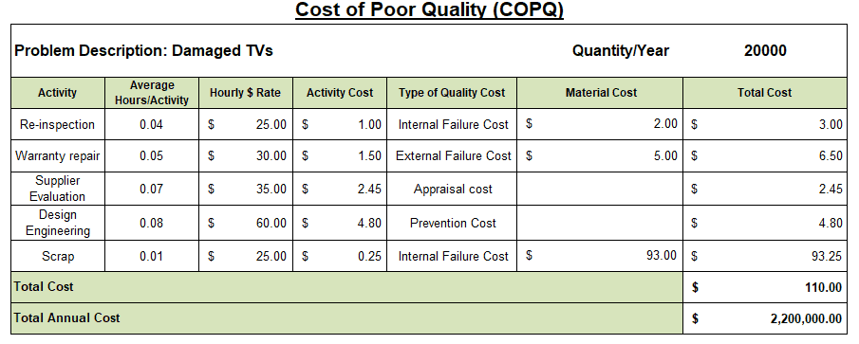
Total material cost is $100 per unit, and an additional $10 per unit is spent on quality costs. At 20k units, that is $200k. The total cost to the company would be $2.2 Million!

