Evaluated Receipt Settlement (ERS) process

CONTENT
- What is ERS
- Basic principles and goals
- Evaluated receipt settlement flow chart
- AS-IS (Paper Invoices) and ERS process
- Advantages of Evaluated Receipt Settlement for the supplier
- Information on settlement using credit note
- Claim processing by the supplier
- Taxation and customs prerequisites
- Purchase order/price change
- Layout and content of ERS self-billing credit note
- What is ERS
Evaluated Receipt Settlement (ERS) are self-billed credit notes to suppliers for the materials supplied, based on prices maintained in the purchase order, and quantity booked during the goods receipt.
ERS Credit note = received Quantity * unit price in the Purchase Order price
- Basic principles and goals
TE Connectivity ("TE") intends to apply the ERS for vendor invoices of ordered goods. This way the business processes will be without any manual interferences and more cost saving. The target is to give suppliers the possibility to be able to work more closely with TE in the context of ERS. A key advantage of ERS for the supplier is quicker and more specific receipt of funds and the removal of the need to issue invoices.
The illustration of the ERS shown below is intended to explain the following new processes:
- The payment/preparation of a credit note is based on a contractually receipt of goods based on the conditions committed with TE.
- Claims based on agreed price changes as well as claims related to the purchase order contents are made by the supplier directly to the responsible buyer.
- Claims in cases of differences between delivery note information and actual quantities delivered are made by the supplier to the responsible planner.
- Other claims or problems are to be addressed to the responsible member of staff in the clearing office/auditing.

- ERS flow chart
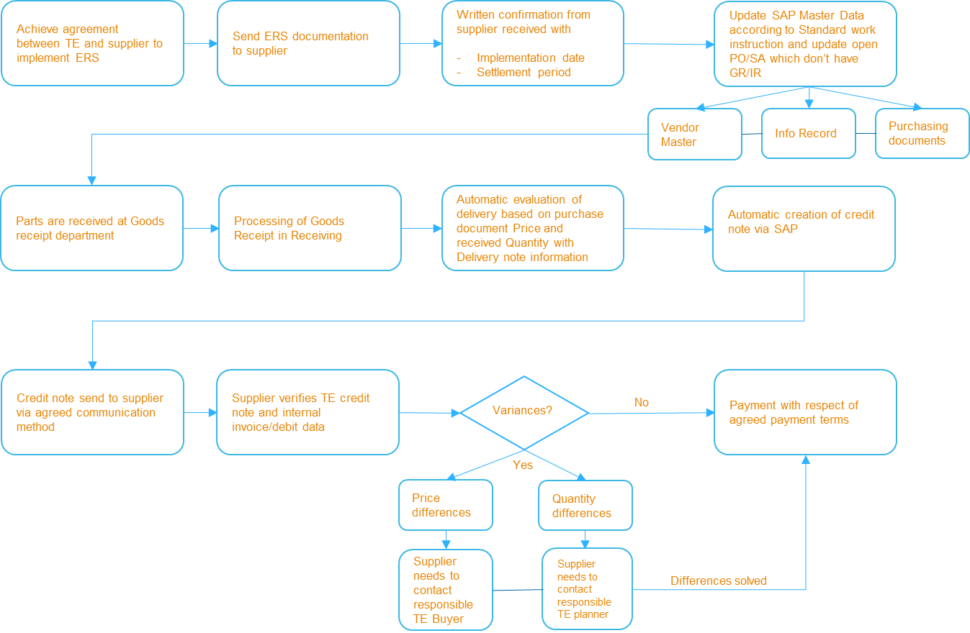
- AS-IS (Paper Invoice) and ERS process
AS-IS PROCESS (Paper Invoices) | ERS PROCESS
Regular PO is created and sent to the supplier | ERS PO is created and sent to the supplier
Vendor creates paper invoice and sends to TE Legal Entity | NA
The Legal Entity scans the invoice to AP Dept | NA
Goods are sent to TE plant | Goods are sent to TE plant
Goods Receipt is posted by warehouse when materials received | Goods Receipt is posted by warehouse when materials received
Invoice is processed by Capgemini AP Department after the paper invoice is received in Legal Entity and scanned to Capgemini | ERS Credit Note is created by AP Dept within 24 hours of the GR booking and PDF copy of CN is automatically triggered to the supplier via e-mail on the same day + excel spreadsheet containing settled document details is sent next day
Several invoices are blocked for Quantity or Price variances | Quantity and Price blocks are eliminated as ERS Credit Note is created based on GR bookings and Purchase Order/info record price
Resolution is awaited from the buyer/planner/TE LE/supplier | ERS credit note is available for payment as soon as it is generated
Invoice is paid as per agreed Purchase Order payment terms – at times late if invoice discrepancy resolution takes longer to resolve | ERS Credit note is paid as per agreed Purchase Order payment terms – always on time and with 100% early payment discount captured

- Advantages of ERS for the supplier
Saving in administrative effort/costs due to the removal of the "paper invoice"
Saving on the administration effort in delivery cycle which eliminates redundant streams of communication and the communication streams that are still necessary are matched to the business process.
Saving in postage and paper costs due to the removal of the invoice.
Improvement in financial planning
As the ERS credit note is prepared daily, the supplier receives early notification of the payment to be expected on the agreed date. The result is a solid basis for improved financial and liquidity planning.
Ability to issue claims to the related departments at an early stage in case of errors
After receipt of the credit note, it can be checked whether all deliveries in the current month are correctly reflected (prices/quantities). Otherwise, a claim can be issued immediately to the related department (procurement or purchasing).
Payment on time
Payment period is only dependent on the date of goods receipt, not in clarification of discrepancies in quantity and price.
Savings in the dunning process
It is no longer necessary to prepare and send a reminder, as well as labour-intensive case-by-case agreement between the supplier and TE auditing.

- Information on settlement using credit note advice
- The data of the invoiced goods receipt, based on the matching delivery note, will be displayed daily in the form of the credit note

- The supplier can compare his delivery data and prices with the credit note and for the purposes of the advance value added tax return, apply an accrual for the deliveries not yet credited by TE at the end of the month
- The data on the credit note are sorted by delivery note number and contain all the information necessary for an accounting record

- Agreed discount percentages are stated on the credit note. The actual deduction of the discount is only made in the payment advice

- As a prerequisite for participation in the procedure, a written agreement between the supplier and TE is necessary. The supplier sends this as an informal confirmation by post/e-mail/fax with reference to the ERS to TE. TE confirms to the supplier the definitive date for implementation of ERS

- ERS credit note will be provided in PDF format. It is also possible, if requested by the supplier, to transfer the credit note data electronically (EDI)

- Claim processing by the supplier
- Claim processing with the planner
Quantity claims or the allocation of quantities and delivery notes can be processed written or by phone with the responsible planner with the following steps:

  - In case of claims please mention the following important details:
  - Number of order document (order or delivery plan)
  - Short explanation of the issue (e.g. delivered quantity does not fit with ERS credit note quantity)
  - The delivery note confirmed by TE warehouse department
  - As we archive delivery notes after 3 months a delayed claim is very labour-intensive and time-consuming. We therefore request you to undertake a quantity and price check without delay on receipt of the ERS credit note

- Claim processing with procurement
Price/purchase order claims can only be processed to the responsible TE buyer

- Taxation and customs prerequisites - applies to countries with VAT
- Taxation prerequisites
Value added tax is addressed based on local tax laws (e.g. clause 14 para. 5 UStG German law on valued added tax). Instead of an invoice settlement can also be undertaken by the recipient using ERS credit notes.
The prerequisite for the application of ERS is a specific contractual transfer of the accounting responsibility to TE.
For the supplier there is no change in relation to his tax authorities. The supplier continues to have the obligation to pay on time to his tax office the value added tax on the deliveries made in the previous month. Instead of his own invoice, the supplier can use the TE ERS credit note.
For material that is in transit at the end of the month (transport) and therefore has not yet been posted as received by TE receiving, the supplier must prepare information internally to determine the VAT for the related month.
Supplier can also within the framework stipulated by law determine his sales based solely on his goods dispatched and use this information for the monthly value added tax declaration. In this case the TE ERS credit note can be used to check the supplier's debt costs and therefore continue to form part of the supplier's accounting and are subject to the corresponding retention regulations.
- Customs prerequisites
For customs purposes, suppliers outside of the EU region must continue to include the related customs papers and the commercial invoice with the delivery. It is not necessary to send a commercial invoice for settlement to TE.
- Value added tax identification number (VAT ID No)
Since the removal of border checks and customs formalities for trade within the European Union, border formalities have been replaced by periodic declarations of EU sales by businesses that are checked by the fiscal authorities.
A key element of this checking system is the VAT ID Nos of the companies involved. Without this information it is not possible for us to settle your deliveries.
Therefore, it is imperative that you provide us – if you have not already done so – with your VAT ID No.
- Purchase order/price change
- Purchase order types included
The purpose of the ERS is that we evaluate your deliveries for:
- Series production purchase orders
- Parts for prototype manufacture
- Test items
- Tool costs
- Equipment and services
- Capital equipment

Automatically with the agreed prices after posting of goods receipt and provide you with a corresponding ERS credit note/debit note.
For you as the provider it is no longer necessary to send an invoice to TE.
All existing purchase orders/delivery schedules remain valid and will be converted to ERS on the agreed implementation date. The new purchase orders/delivery schedules which are processed using ERS, a corresponding note will be added.
- Backdated price change
If a backdated price correction is made by procurement, we will prepare ERS credit note/debit for the difference including VAT disclosure taking into account corrections already made, for each delivery affected.
- Layout and content of ERS credit note
